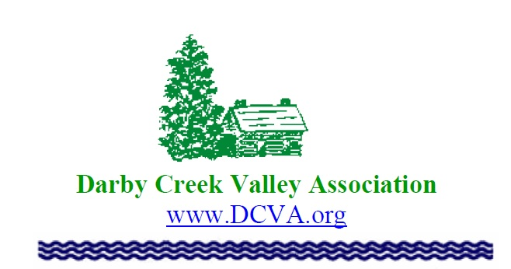

Membership Application

The Darby Creek Association (DCVA) is dedicated to the protection and enhancement of all of the watershed’s resources, including water, wildlife, historical sites, and the floodplanes. The organization immediate goals are to prevent all forms of pollution in the Darby Creek and its tributaries, to prohibit dumping and construction on the floodplain and to expand our educational programs for all residents within the watershed. It also seeks to improve water quality and maintain a debris-free stream through clean-ups and public education. DCVA works to preserve historical properties, such as the Swedish Cabin, and the Blue Bell Inn. The association would like to set aside more than 30 miles of the valley for use as a greenway for all residents to enjoy. We need your support. Help us continue to protect the environment for ourselves and our children.

We invite you to fill in the form below, check member category, and mail form along with your check made out to DCVA to:
The Darby Creek Valley Association, P.O. Box 732 , Drexel Hill, PA 19026

Name:_______________________________________________________Date:_____________
Address:_______________________________________________________________________
City:_______________________________, State:_________, Zip_________________________
Phone:________________________________ Email:__________________________________
Student/Senior $15______ Individual $25_____ Non-Profit $40_____ Family $40_______
Corporate $100_______ Life________ Extra amount:________________
Total Inclosed:__________________
DCVA is a 501(c) 3 Non-profit Organization. All donations are tax deductible.

